MACH4METAL

metalworking machinery
Transito 21,
6909 DA BABBERICH, Netherlands
Tel. + 31 (0)316 – 247123
Fax. + 31 (0)316 - 247956
info@mach4metal.com
www.mach4metal.com

Bank No : 66.52.13.883
IBAN : NL33 INGB 0665 2138 83
BIC : INGBNL2A

OM Vertical borer Ø 4000
single column with displaceable table

- Make : OM LTD Japan
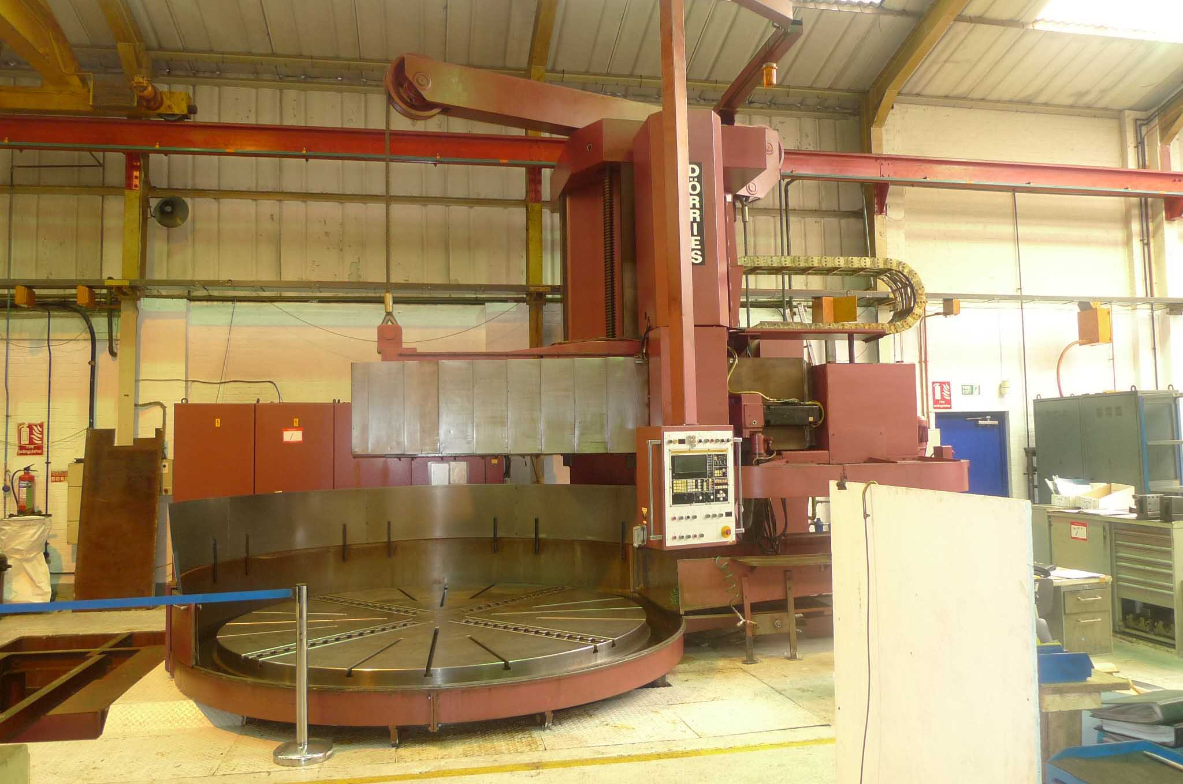
- Typ : TSM-2 20 / 40
- Age : 60 er
- Serial.No :

- Chuck Ø : 1.900
- Sub table :
- Maximum swing : 4.000

- Max. turning height cross rail : 1.800
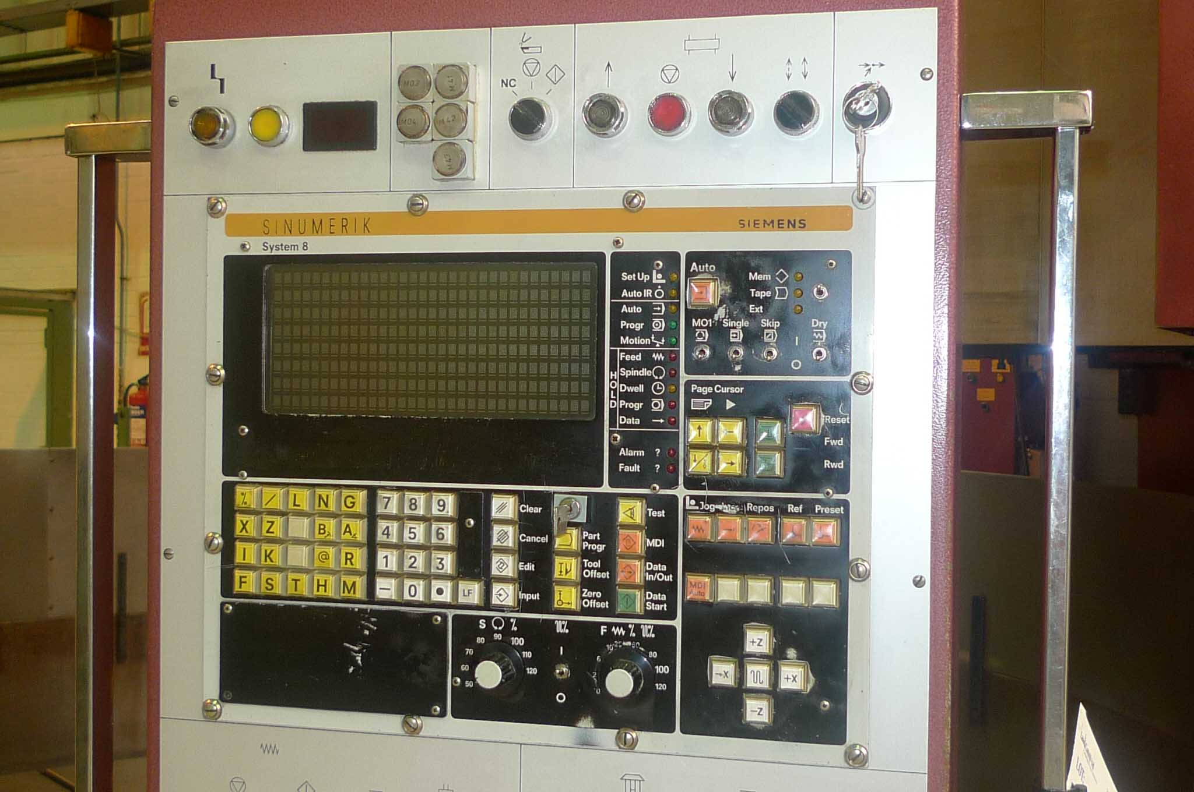
- Max. turning above table : 2.000

- Stroke Tool holder : 1.250
- Cross rail adjustment : 1.500
- Table load : 60.000

- Tool shank size : 40 x 40
- Max. cutting power : 75000
- Max. torque on table : 60000
- Power main motor : 75 kW / 415 V
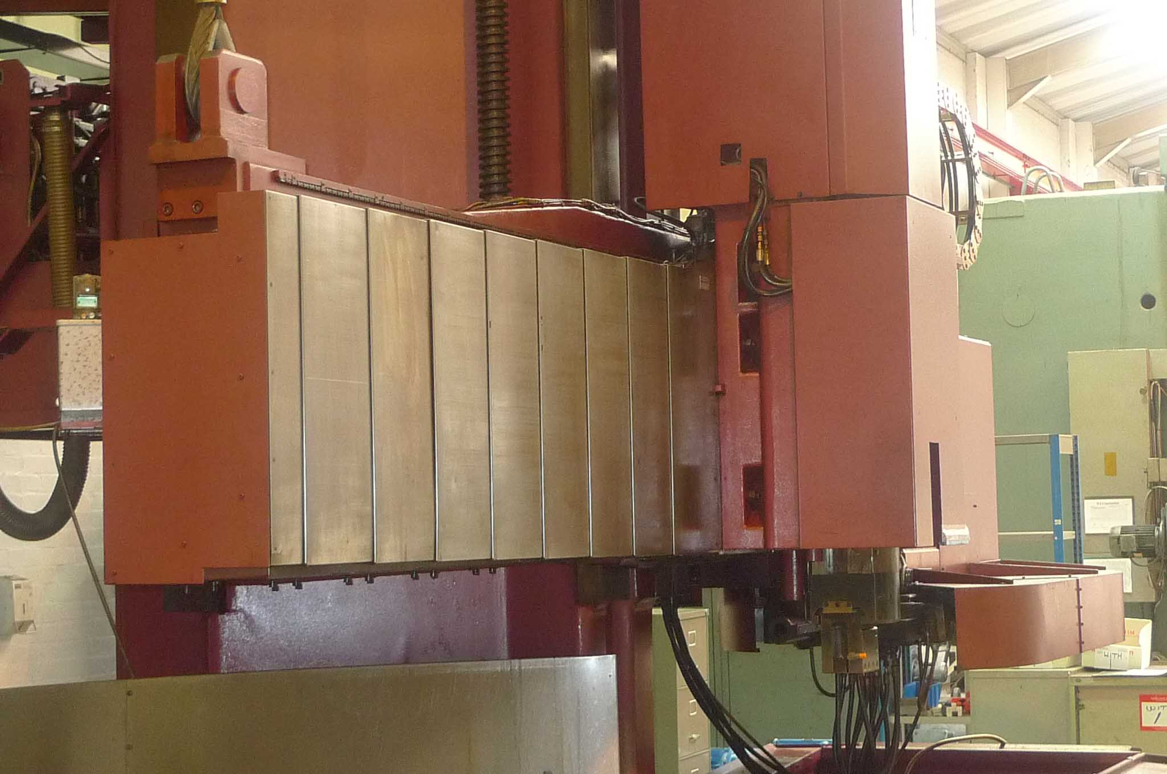

- Speeds 1 / 2 / 3 Range: 0,8 – 100 Omw/min
- Feeds Vario : 0,1 – 1.000 mm/min
- Rapid Feed : 6.000 mm/min

- Dimensions: 9,30 X 6,10 X 6,30 X 60 ton
- CNC Siemens Sinumriek System 8
- Tool changer 16 positions
- SCR Feed drives / each Axis own drive
- Ballcrews + Slide roller guideways
- Displaceable table hydraulic / manuel
- Circular interpolation

Please Note: The above information has been obtained to the best of our ability and belief from, and from the manufacturers where possible. It is given in good faith, but its accuracy can not be guaranteed. Accordingly, it will not form a representation or constitute contractual terms. We advise you to check any vital details

